<https://github.com/espressif/arduino-esp32>

install json using Arduino IDE Boards Manager

<https://github.com/espressif/arduino-esp32/blob/master/docs/arduino-ide/boards_manager.md>

open Arduino IDE

Go to File 🡪 Preferences

Add <https://raw.githubusercontent.com/espressif/arduino-esp32/gh-pages/package_esp32_index.json> to additional board manager URLS

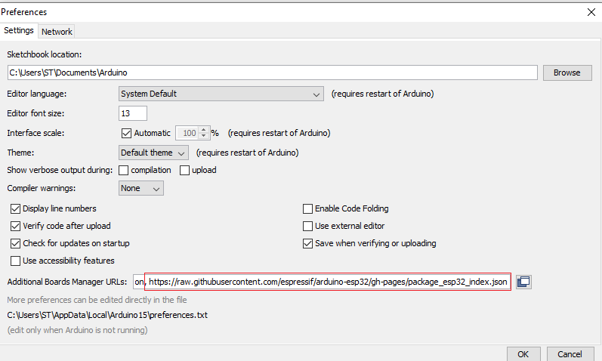

Tools 🡪 Board Manager

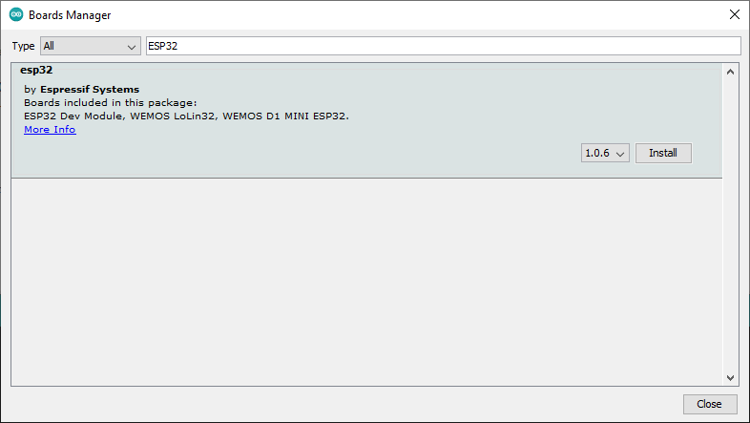

Press install

Select the board

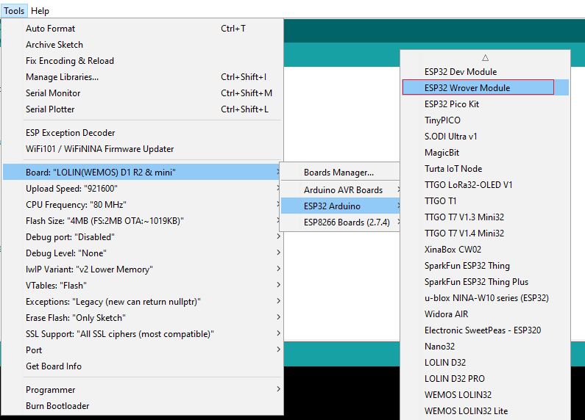

Install “cp2104 usb to uart bridge controller” driver

<https://www.silabs.com/developers/usb-to-uart-bridge-vcp-drivers>

Device manager, find new com port, in Arduino IDE go to Tools 🡪 port

